**SYSTEM DOCUMENTATION**

**Student information system**

**SOFTWARE AND HARDWARE REQUIREMENTS**

Software

* Web browser (Google chrome, IE, Opera, Microsoft edge).
* Local web server (Xampp Apache) >= version 8.1.

Download - <https://www.apachefriends.org/>

* Application dependency manager for PHP. (composer).

Download - <https://getcomposer.org/>

* Windows operating system (windows 10 of higher recommended).
* PHP version >= 8.1

Hardware (Minimum requirements)

* Processor Intel(R) Pentium(R) CPU N3710 @ 1.60GHz 1.60 GHz or higher
* Installed RAM 4.00 GB (3.84 GB usable) or higher

**Frameworks/libraries.**

* Laravel v.10 - Laravel is a free and open-source PHP web framework, created by Taylor Otwell and intended for the development of web applications following the model–view–controller (MVC) architectural pattern and based on Symfony.

<https://laravel.com/docs/10>

* Bootstrap 5 - Bootstrap is a free, open-source front-end development framework for the creation of websites and web apps. Designed to enable responsive development of mobile-first websites, Bootstrap provides a collection of syntax for template designs.

<https://getbootstrap.com/docs/5.3/getting-started/introduction/>

* Jquery-3-5-1 - is a lightweight, "write less, do more", JavaScript library. The purpose of jQuery is to make it much easier to use JavaScript on your website. jQuery takes a lot of common tasks that require many lines of JavaScript code to accomplish, and wraps them into methods that you can call with a single line of code.

<https://jquery.com/>

* Fullcalendar.js. - is a JavaScript library that seamlessly integrates with such popular JavaScript frameworks as Vue, React, Angular. Thanks to its excellent documentation, one won't have trouble incorporating the library into projects.

<https://fullcalendar.io/>

**Getting started – Installation**

1. After Satisfying the minimum software and hardware requirements download and extract the zip file in this link.
2. We need to setup our local web server to run our database. After installing xampp, open the xamp-control-panel and start apache and mysql.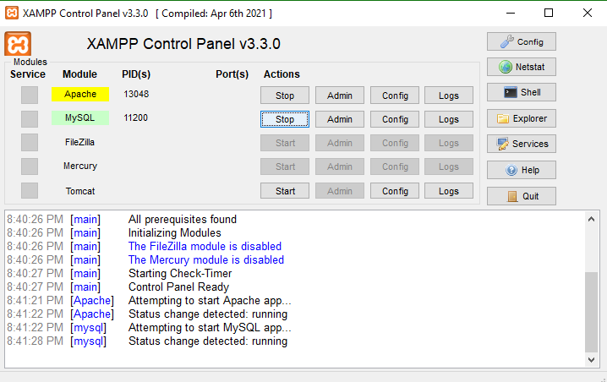
3. Open the brower the go to localhost/dashboard and click “phpMyAdmin”.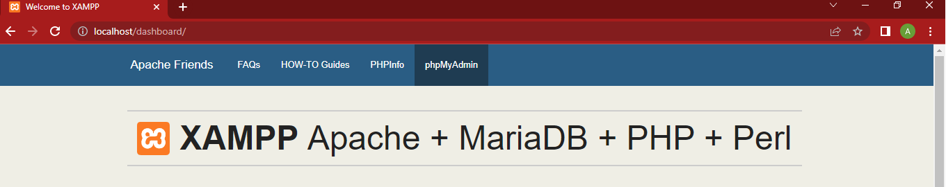
4. Create a new database and name “studentinfo”.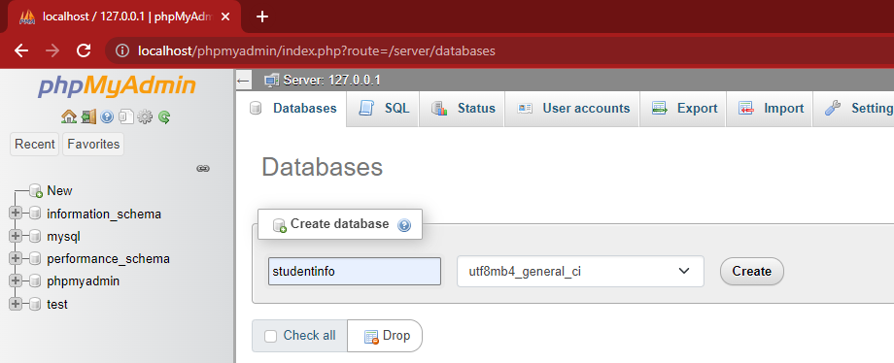
5. After successfully creating a database. Open the command prompt at the project’s directory.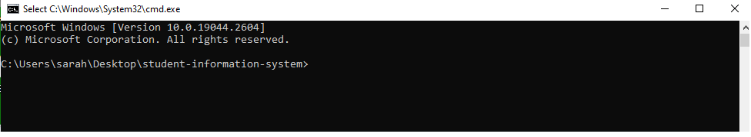
6. Using the command “php artisan migrate” it will automatically create tables in our database.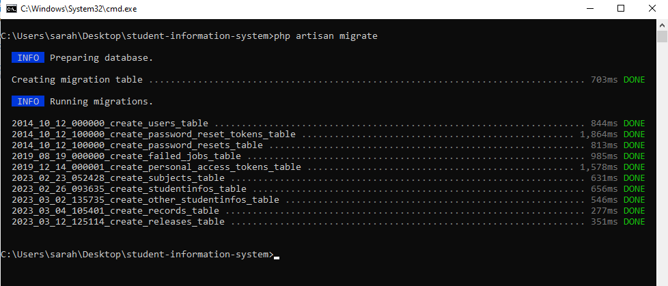

Your terminal should contain like this, to ensure that the migration is successful.

1. After migrating database files. Now, we can run the application using the command “php artisan serve”.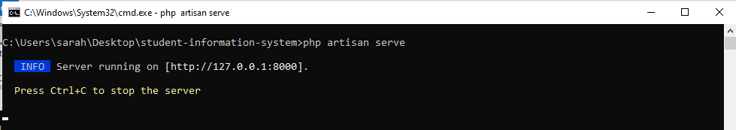

After running the command, we should be able to see this in our terminal, if yes then we can navigate to <http://127.0.0.1:8000> or <http://localhost:8000>.

**Application Usage**

1. For every time that we are going to use the application, we need to repeat the step no. 2, 5 and 7 in installation manual. If this is the first time of using the application, we will be automatically redirected to <http://localhost:8000/register> to setup our account if not to <http://localhost:8000/login>.
2. For setting up an account. We need to fill up all necessary fields to complete registration.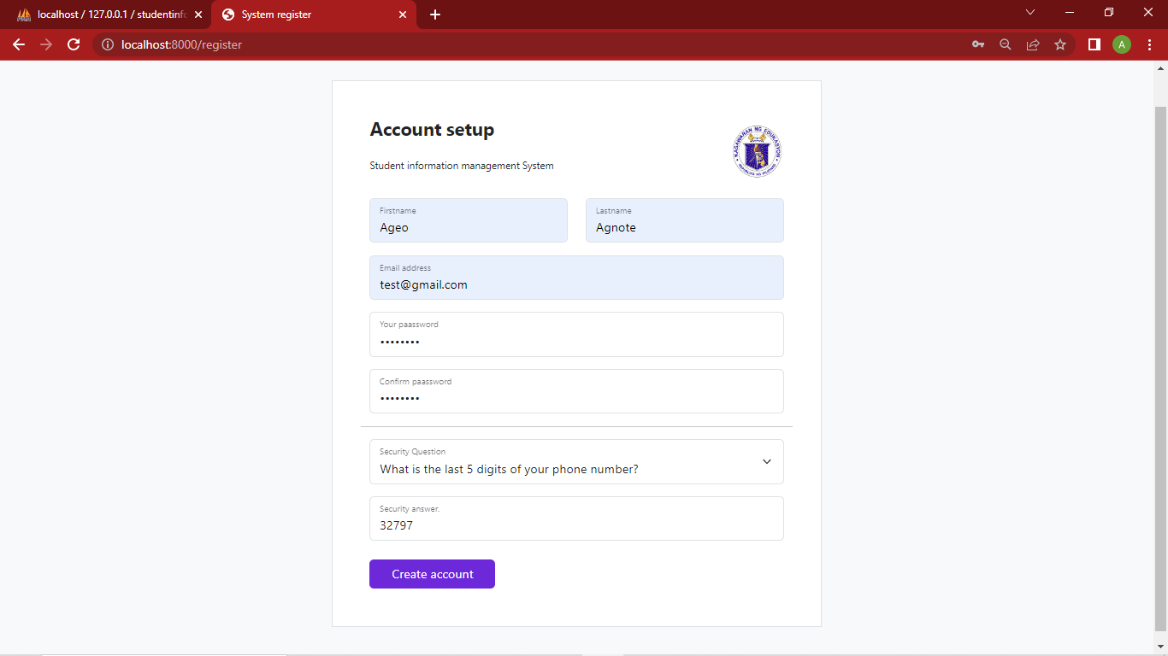

If success we should be able to see a message presented below. And be automatically redirected to <http://localhost:8000/login>.

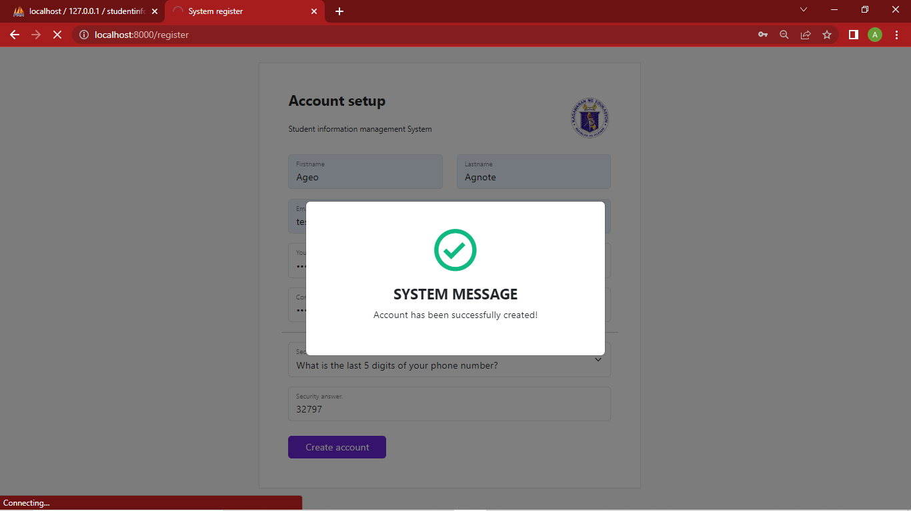

1. <http://localhost:8000/login>, here we will be able to see email and password fields for user authentication.

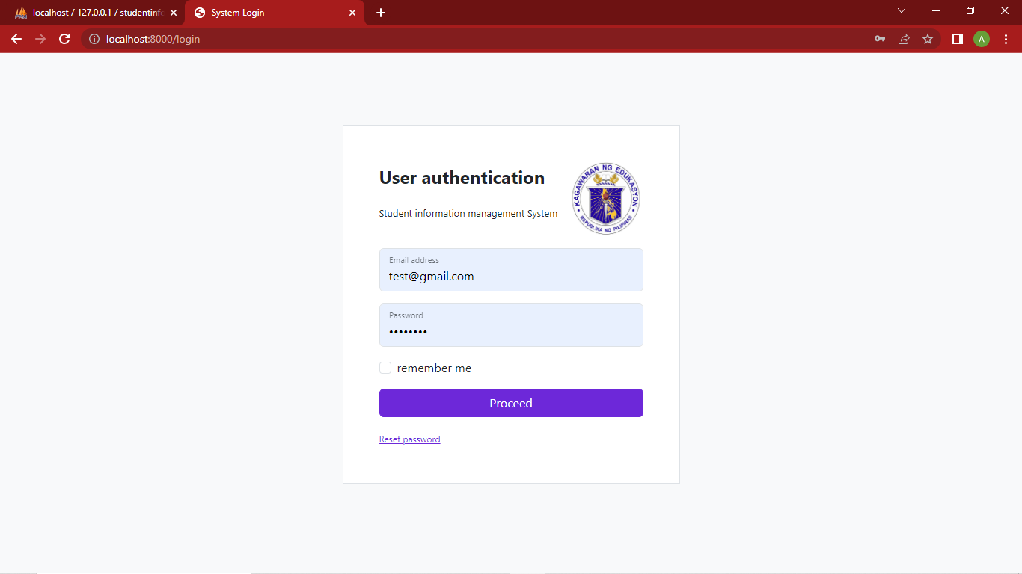

1. After logging in we, should be redirected to <http://localhost:8000/dashboard> or like the image below, which contains a side bar menu (Home, data management and release) at the left side and the main content section to the right side. In home menu we should be able to see some basic information’s about the collections of data in our database.
   1. Students – refers to the no. of student record in our database.
   2. Academic records - refers to the no. of academic records in our database.
   3. Recently release – show the list of record that has been recently released.

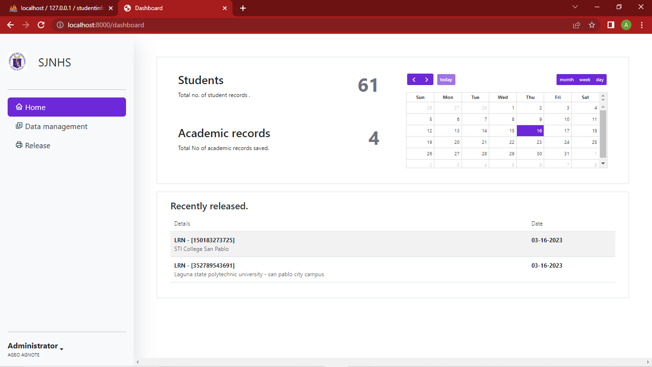

1. When managing or adding a new subject/student we can simply click the data management link in the side bar menu. To manage subjects, click the manage subject button in the upper right. While in creating a student record click the add student button in the upper left of the main content section of the page.

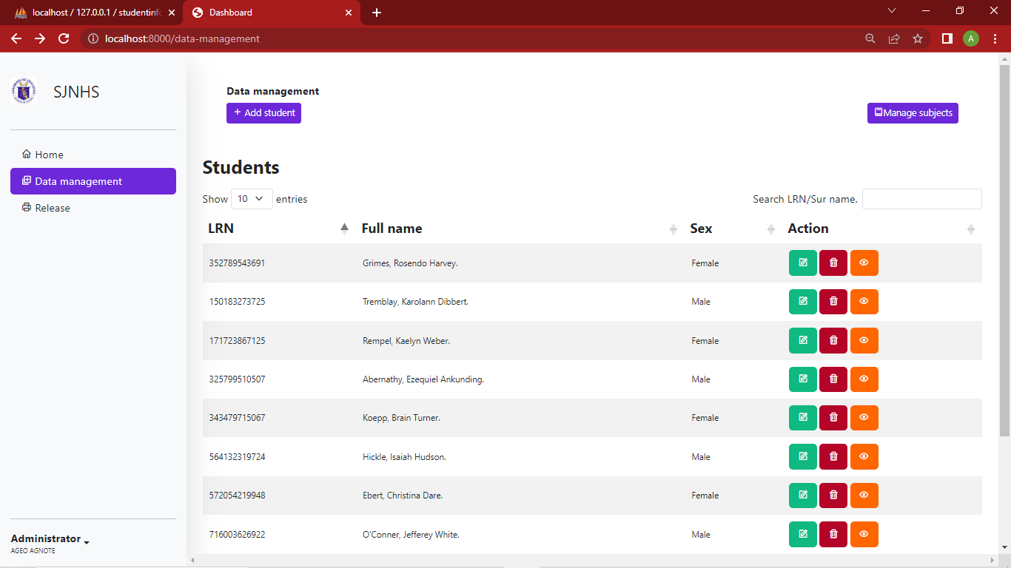

We should be able to see image below. In this URL - [http://localhost:8000/data-management/subjects](http://localhost:8000/data-management/subjectss) we are allowed to perform create, read, update and delete operations.

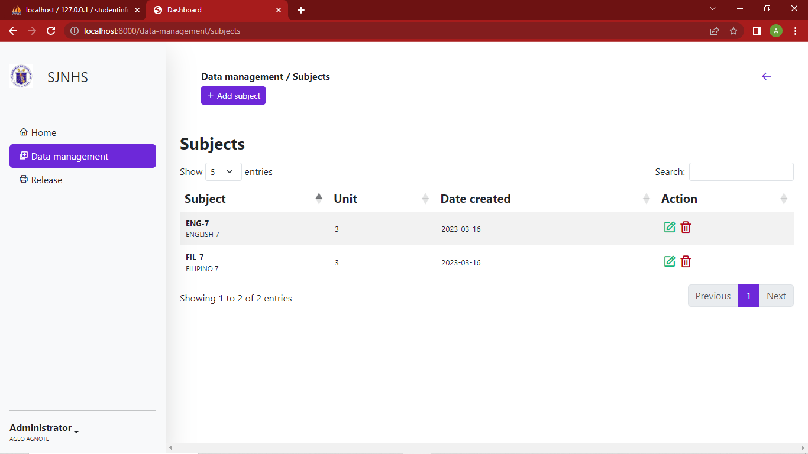

In creating student record just simply fill all necessary fields.

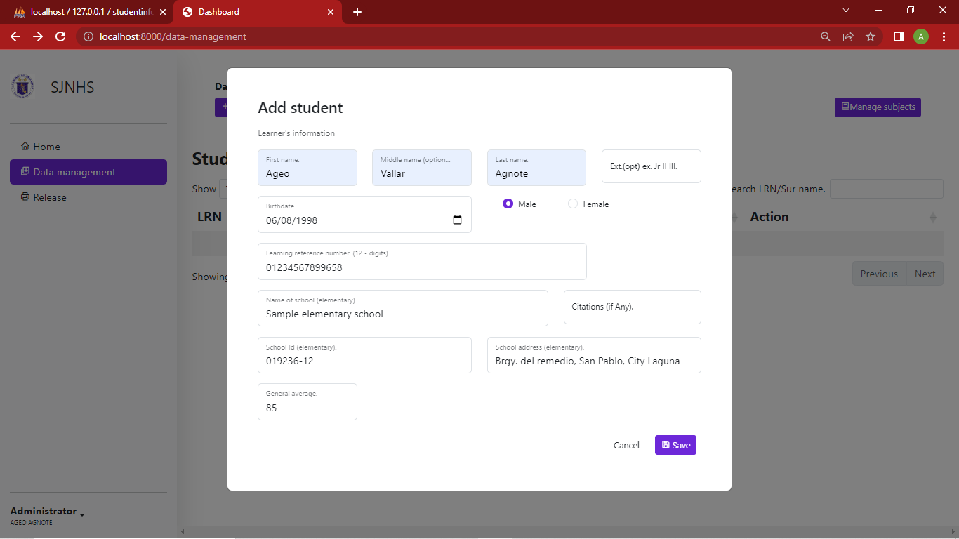

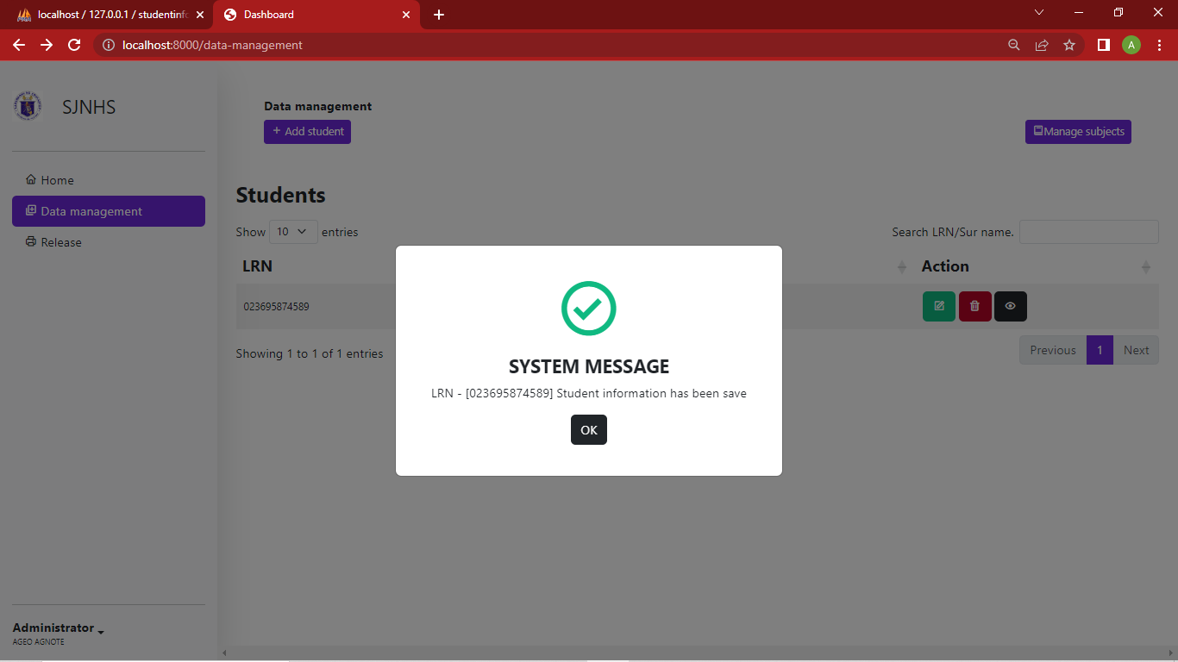

1. To Update and to add academic records to a student record. We can simply click the green button in action column and we will be redirected to a new page containing editable fields for the record and a button in the upper left for viewing/managing academic records of the selected student record.



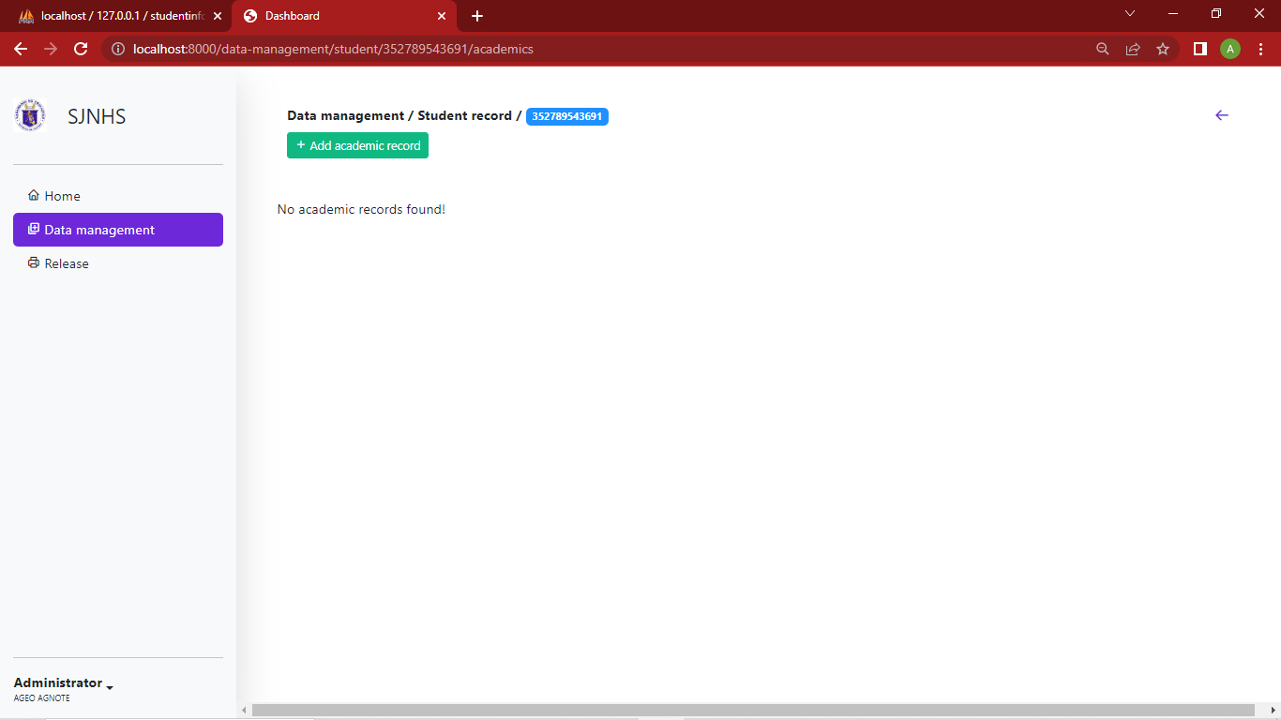

After clicking the view records, we should be able see the image above. And to add a new academic record for the selected student simply click the add academic record. A modal will popup containing fields for the academic record.

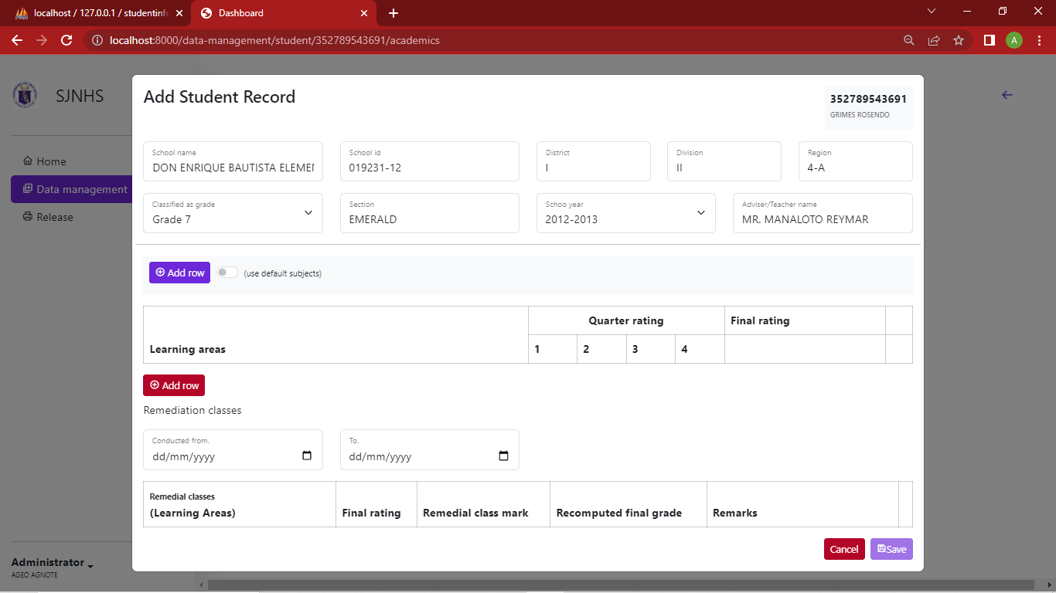

To add this academic record, we should fill up all the necessary fields that system needs you to fill out or else it will show you the errors.

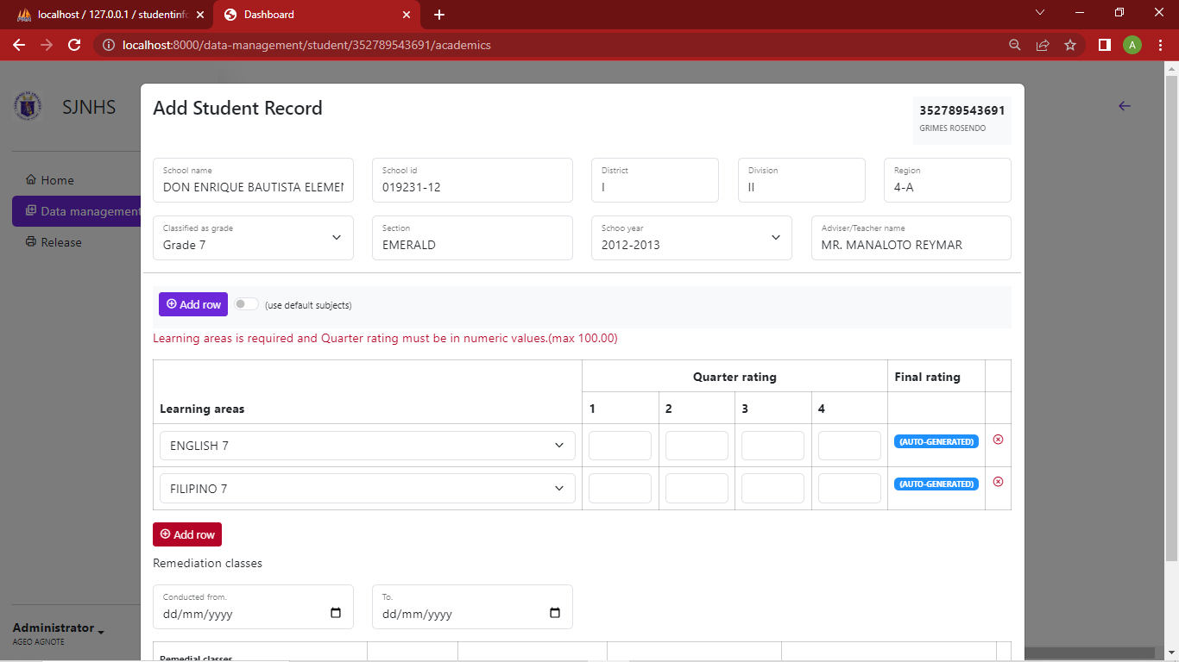

Learning areas are required and the values for the quarterly rating should be in non-negative numerical values. Here final rating is automatically generated when saved. Adding remedial records is same as adding a row in academic records but the most of the values are optional.

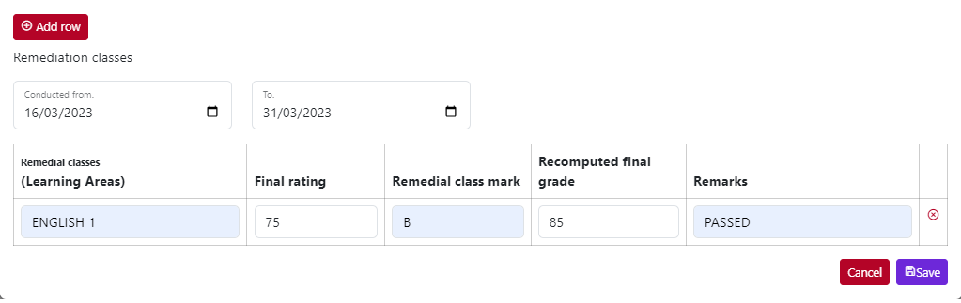

To lessen our time in adding a row one-by-one we can toggle the use default subjects, a rows of subjects should appear like the image below.

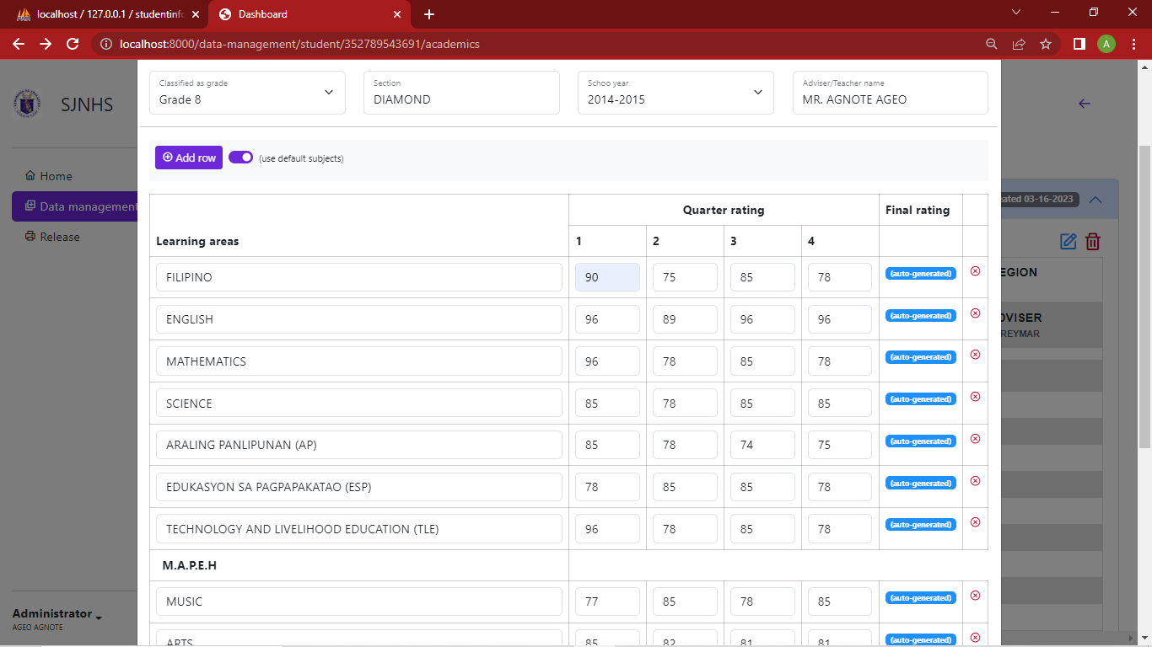

After saving we should be able to see the list of academic records of the student like the image below.

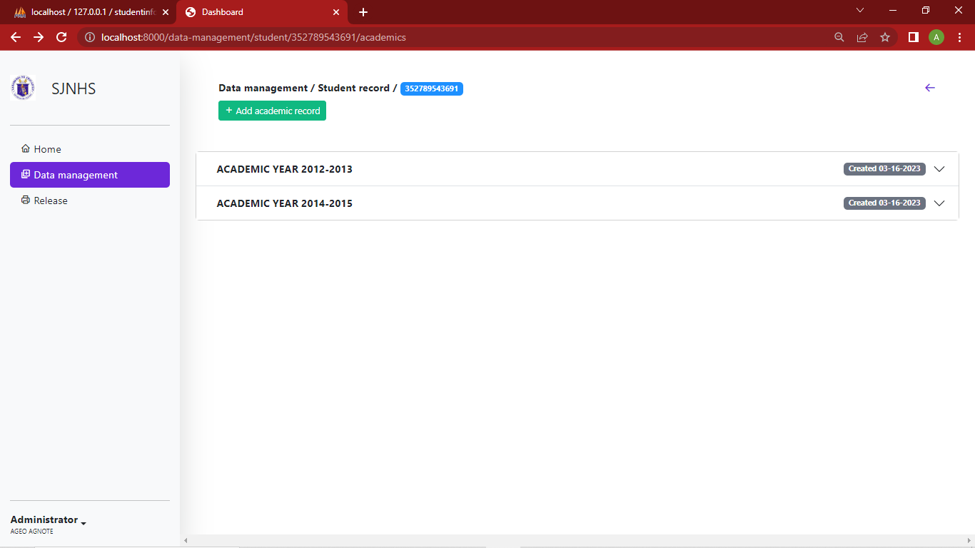

Here we can see a list of collapsible items that if we click it, we should be able to see the data of academic record, edit and delete button on the upper right of the collapsible item.

1. To view and print a student record. We can click the orange button in action column. It will open a new tab containing all the data of the record.



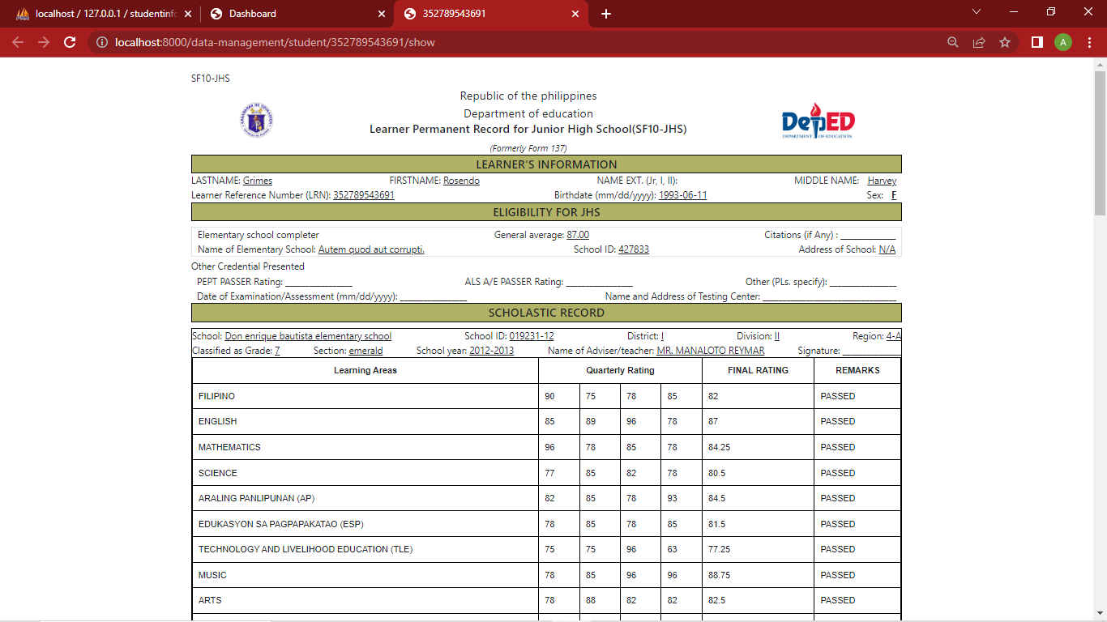

Here we have the options to directly print the page by pressing (**CTRL + P**) or save it as a pdf like the image below).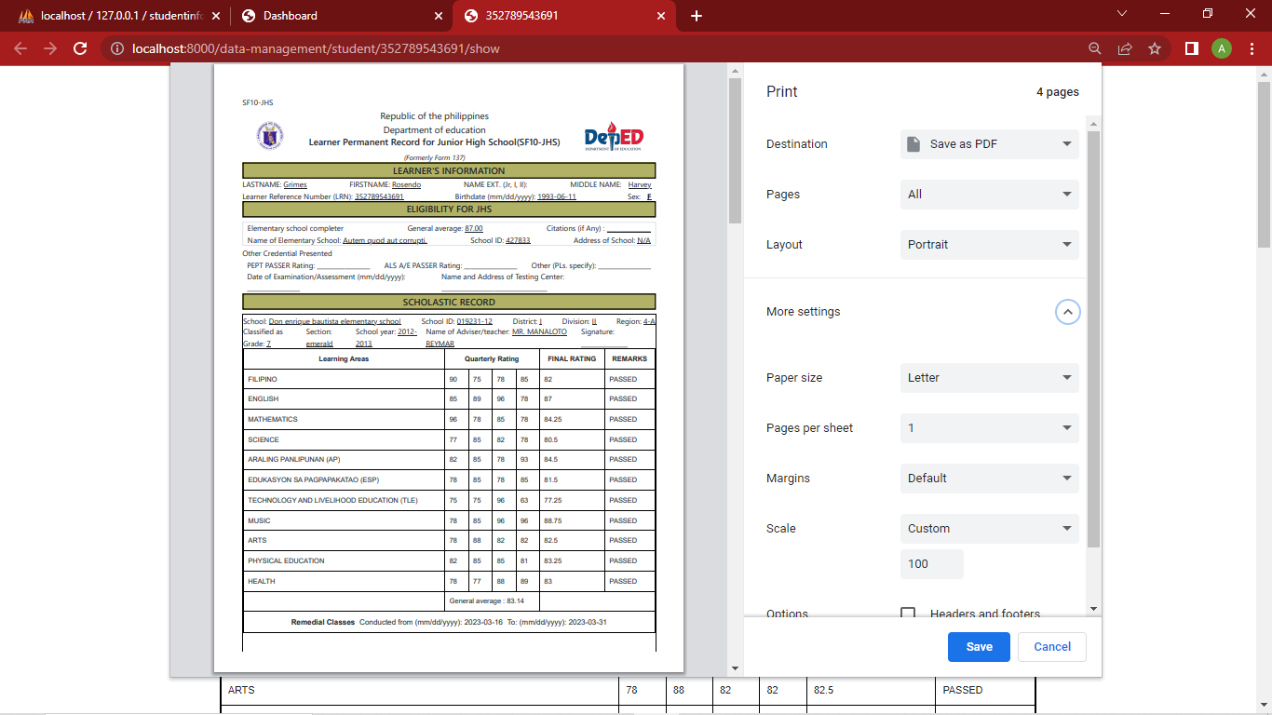

1. To configure our personal information and account credentials we can navigate to <http://localhost:8000/settings> by simply clicking the setting item in bottom of side bar menu.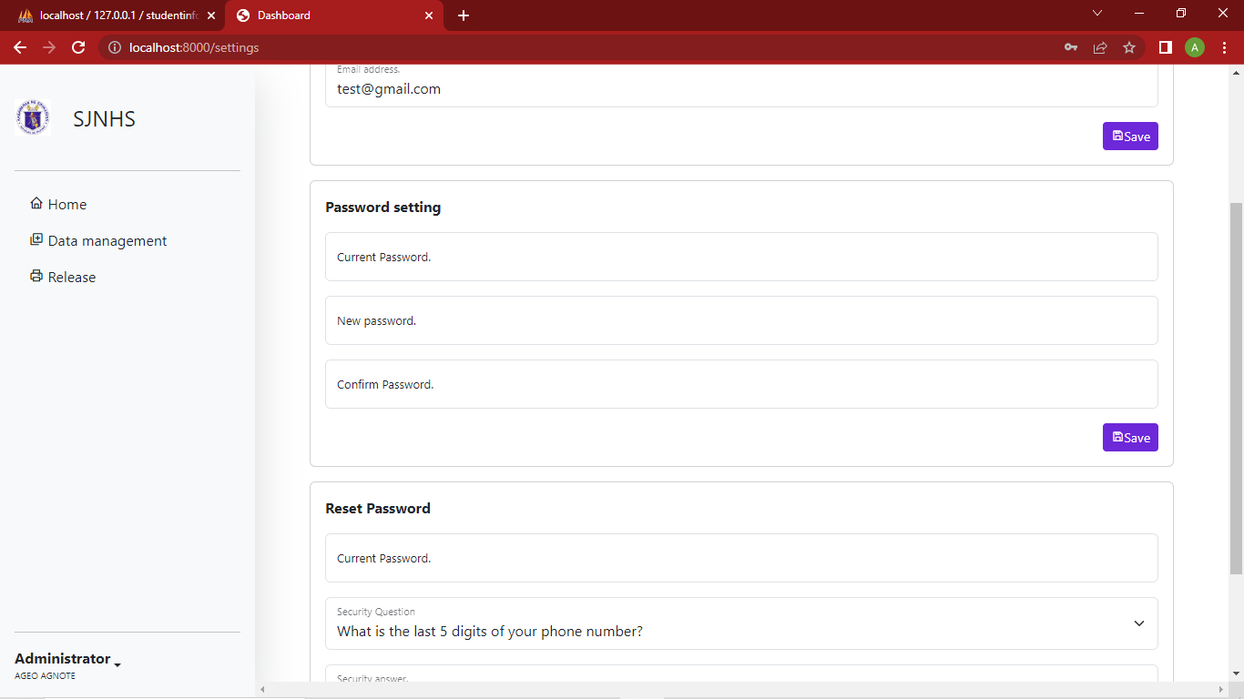

Here we can modify our account information such as names and passwords.

1. When adding a released record, we can navigate to <http://localhost:8000/released> here we can see fields for LRN and name of school or institution that is requesting form 137. When saved a log for the released will be recorded. 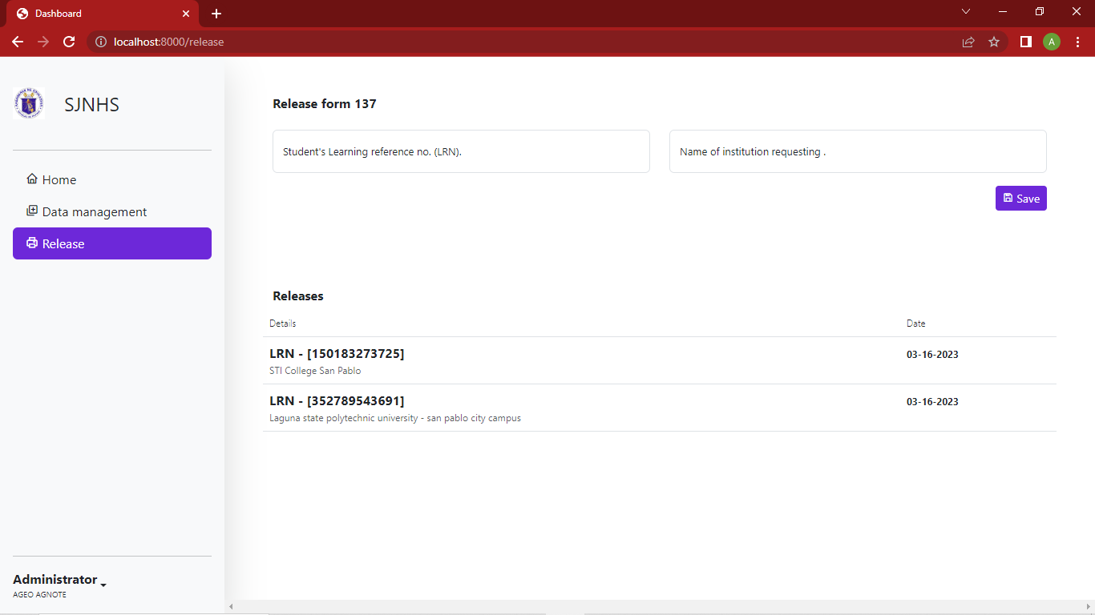
2. In case we forgot our password and can’t get access to the system. In login page we can see a link for reset password page. But before that, we need to ensure that the value of email field contains an existing user email or else it will show us an error.

After a successful request, we should be able to see image below for user verification. Here, we are using security question and answer to verify the user. We need to submit the valid values for security answer in order to proceed.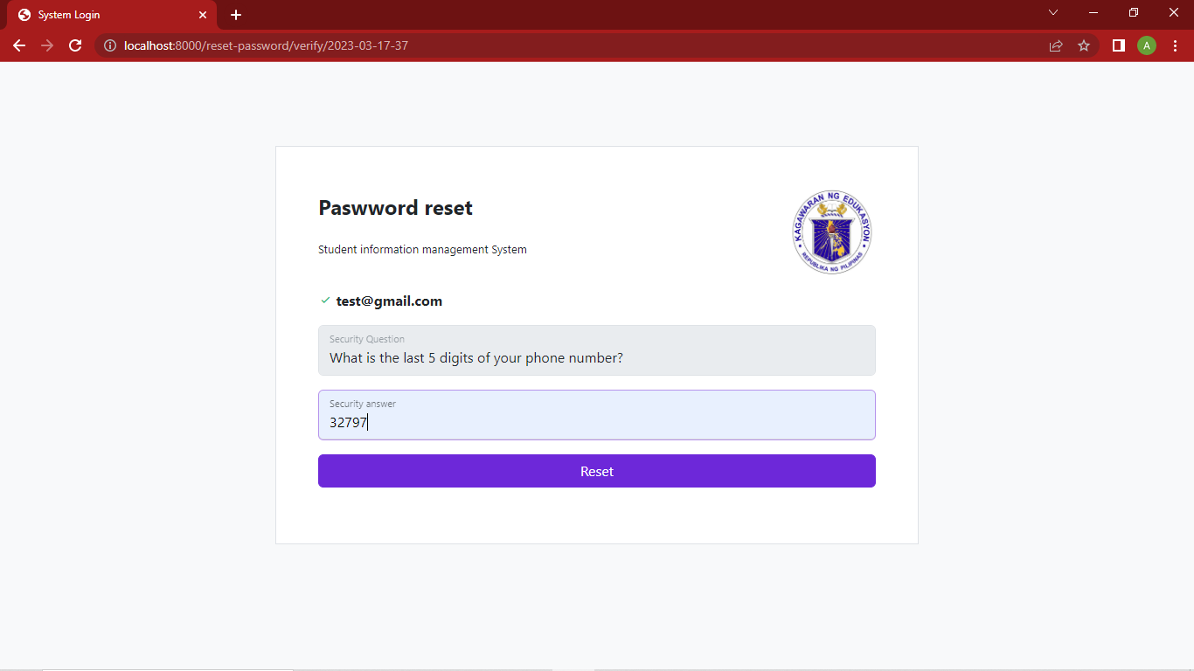

After the image above, we should be able now to save a new password for our account.

